ERD Assignment 2

Please double-click “Name” above and enter your name.

Please fill in your answers in the spaces provided and submit this file on Blackboard. Please submit it as a Word document only – do not convert to PDF.

* When asked to draw ERDs, please draw them in Oracle Data Modeler and then paste the image file into this document at the appropriate place.
* For answers that you type in, please use the Arial Black font so that I can locate your answers easily.

1. Based on the diagram below, answer the questions that follow the diagram. **When asked to count attributes, you should count all attributes – including implicit foreign key attributes**.   
   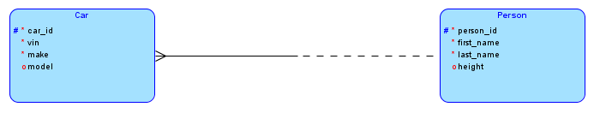

* Primary key for Car:
* Primary key for Person:
* Number of attributes for Car:
* Number of attributes for Person:
* Number of optional attributes for Person:
* Number of required attributes for Car:
* Degree of the relationship:
* Entity type(s) that has (have) obligatory participation:

1. There are many books and persons. Each book is authored by one or more persons and each person might be the author of zero or more books. A designer created the following ERD first, with the m:n relationship and then refined it with the associative entity Book-Author as shown in the next diagram (we have not shown the three entity types in one line, but the meaning remains unchanged). Use the second diagram below to answer the questions that follow it.

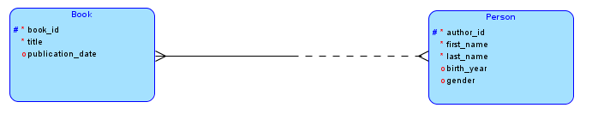

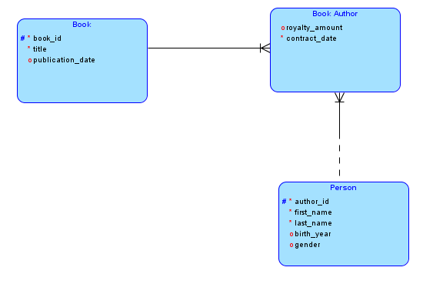

* Number of attributes for Book-Author:
* Number of required attributes for Book_Author:
* Primary key for Book-Author:

Draw ER Diagrams for questions 3 to 6. Use proper cardinality notation showing both degree and participation. Use Oracle Data Modeler to draw the ERDs and export the diagrams as image files and paste in this Word document..

1. Every employee is assigned an office. An office might be assigned to one employee or might be empty.  
     
   (Paste your ERD here.)
2. Each car company might be the manufacturer of many models of cars or the company could be new and might not have any models yet. Every model of car is made by exactly one company.  
     
   (Paste your ERD here.)
3. An apartment rental company owns many apartment complexes across the country. Each complex has a unique id, complex name, year it was built in and street, city and zip. Each apartment complex has many buildings. Each building has a building number, the date it was last painted and the style of the building. The building number is unique within a complex, but not across complexes. To uniquely identify a building, we need the id of the complex and the building number.  
     
   (Paste your ERD here.)
4. The ERD below shows that a supplier might be the supplier of one or many parts, and that zero or several suppliers might supply a part. For example, supplier 1 supplied 200 units of part A on Jan 5, 2011 and supplier 2 supplied 300 units of part B on Feb 1, 2012. Supplier 1 also supplied 150 units of part B and 65 units of part C on March 2011. Part D has not had any shipments so far. For now, assume that we need to store information only about the latest shipment that suppliers made of each part that they supplied.  
     
   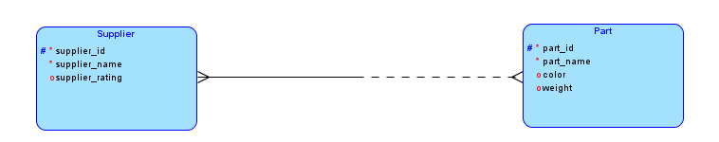

As we discussed in class, whenever we have a m:n relationship, we always convert it into an associative entity. Draw the ERD with the associative entity – you need to show only one non-key attribute for the associative entity.. Use proper cardinality notation and also show the primary key for the associative entity using appropriate notation.

(Paste your ERD here.)